DAD 220 Project One Template

Complete these steps as you work through the directions for Project One. Replace the bracketed text with your screenshots and brief explanations of the work they capture. Each screenshot and its explanation should be sized to approximately one-quarter of the page with the description written below the screenshot. Follow these rules for each of the prompts and questions below. Review the example document in the Supporting Materials section of the Project One Guidelines and Rubric for assistance.

Step One: Create a Database

- In your online IDE (Codio), create a database schema called QuantigrationUpdates that will hold tables by using SQL commands.
  - List out the database name on the screen.
  - Provide the SQL commands you ran against MySQL to complete this step.

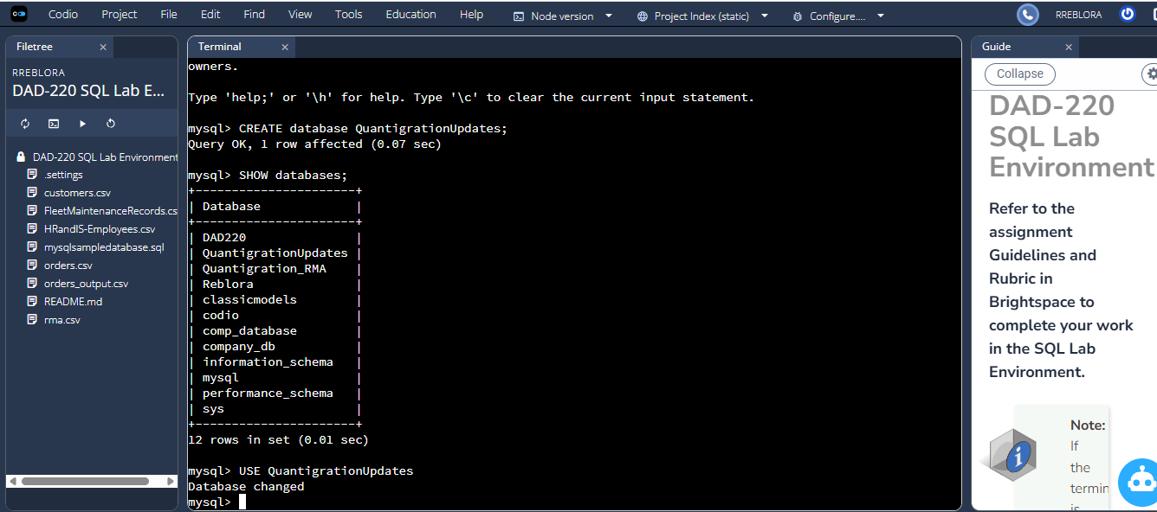

- Connect to the QuantigrationUpdates schema. Using the ERD as a reference, write SQL commands to create the following tables with the appropriate attributes and keys to demonstrate relationships based on the ERD.
  - A table named Customers to store customer information with a primary key of Customer ID. Provide the SQL commands you ran against MySQL to complete this step.

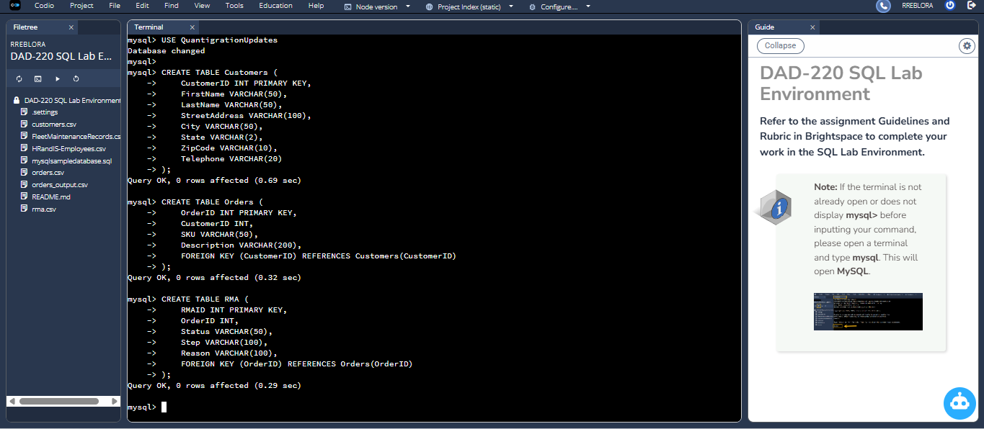

  - A table named Orders to store order information with a primary key of Order ID and a foreign key of Customer ID. Provide the SQL commands you ran against MySQL to complete this step.



OrderID is the primary key, and CustomerID is a foreign key that links each order back to the customer who placed it.

  - A table named RMA to store RMA information with a primary key of RMA ID and a foreign key of Order ID. Provide the SQL commands you ran against MySQL to complete this step.



RMAID is the primary key and OrderID is the foreign key that is used to create a relationship between each RMA record and the order.

Step Two: Load and Query the Data

- Import the data from each file into tables.
  - Use the QuantigrationUpdates database, the three tables you created, and the three CSV files preloaded into Codio.
  - Use the import utility of your database program to load the data from each file into the table of the same name. Perform this step three times, once for each table.
  - Provide the SQL commands you ran against MySQL to complete this step.

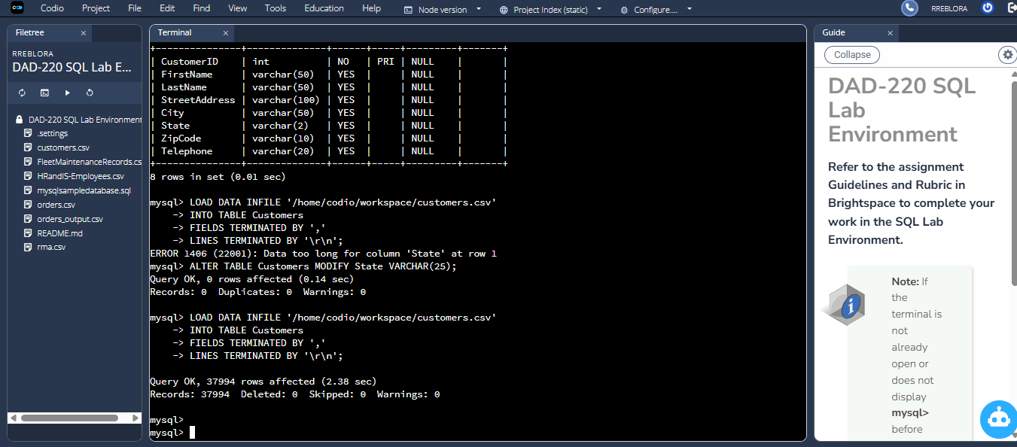

- I GOT THE ERROR "ERROR 1406 (22001): Data too long for column 'State' This means the value in the “State” column in customers.csv is longer than my column size. And in my ERD, State = VARCHAR(25) But my table currently has: State VARCHAR(2) because we originally used a shorter version, and now it’s causing the import failure. so i had to alter it and change it too VARCHAR(25).

- 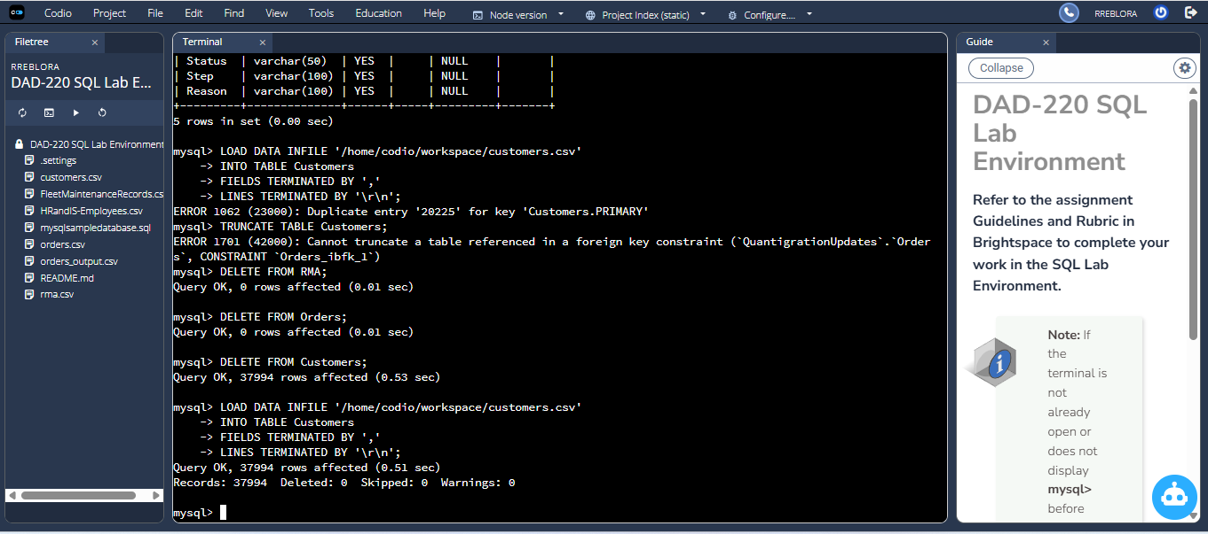

Error: “Can’t truncate a table referenced in a foreign key constraint”
I got this message because MySQL prevents truncating a table if another table depends on it through a foreign key. Since the Orders table has a foreign key to the Customers, MySQL blocked the TRUNCATE function. For this, I first deleted rows from the dependent tables (Orders and RMA), which removes the foreign key dependency. The Customers table would be cleared and reloaded.

Error: “Duplicate entry '20225' for key 'Customers.PRIMARY'”
This was a result of my attempt to upload the customers.csv file twice. The column CustomerID is a primary key, and the values of a primary key are required to be unique. MySQL caught that CustomerID 20225 already existed and blocked the attempt to add more data with duplicate key values.
The solution was to delete the data first, then reimport the CSV so the file could be inserted without duplication of primary key values.

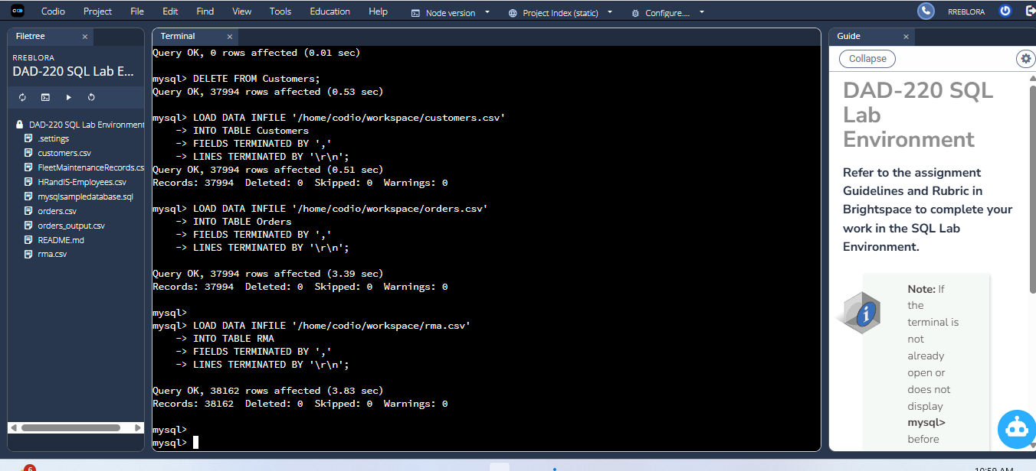



- Write basic queries against the imported tables to organize and analyze the targeted data. For each query, replace the bracketed text with a screenshot of the query and its output. Also, include a one- to three-sentence description of the output.
  - Write a SQL query that returns the count of orders for customers located only in Framingham, Massachusetts.
    - This query will use a table join between the Customers and Orders tables. The query will also use a WHERE clause.
    - How many records were returned?
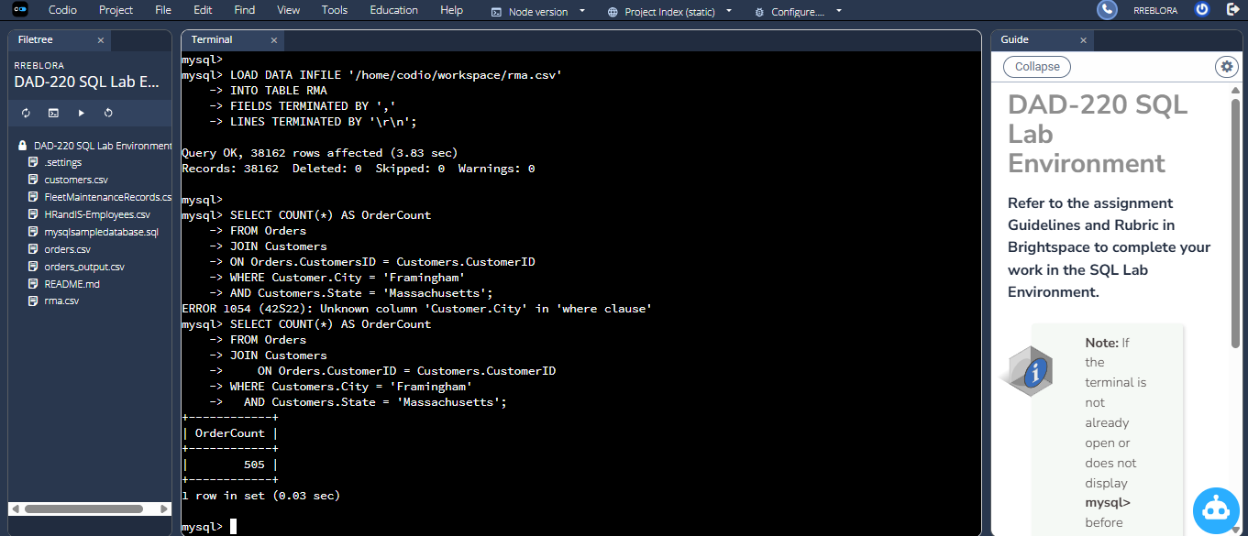

- The SQL statement counts the number of orders from customers in Framingham, Massachusetts. It joins the Orders and Customers tables using the common field CustomerID. The WHERE clause filters further to only count orders where City = 'Framingham' and State = 'Massachusetts'. The output indicates that 505 orders meet this criterion.

  - Write a SQL query to select all of the customers located in Massachusetts.
    - Use a WHERE clause to limit the number of records in the Customers table to only those who are located in Massachusetts.
    - How many records were returned?
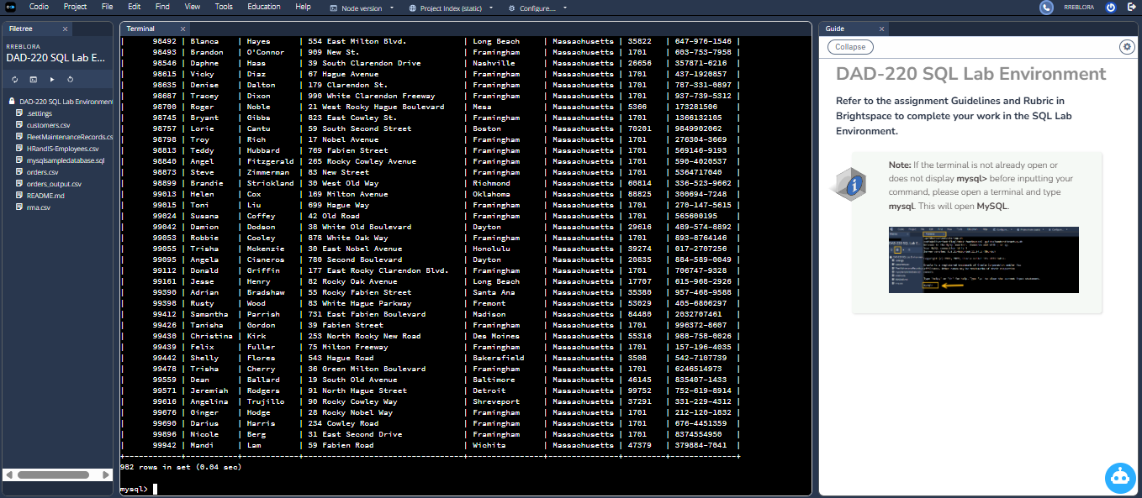

- I ran this query to produce that result it was just too long to scroll all the way up to get the screen shot. This query returns all customer records where the state of the customer is Massachusetts. The WHERE clause filters the Customers table to only include Massachusetts customers in the results. Based on the output, the query returned 982 customer records.

  - Write a SQL query to insert four new records into the Orders and Customers tables using the data below:

Customers Table
CustomerID | FirstName | LastName | StreetAddress | City | State | ZipCode | Telephone
100004 | Luke | Skywalker | 15 Maiden Lane | New York | NY | 10222 | 212-555-1234
100005 | Winston | Smith | 123 Sycamore Street | Greensboro | NC | 27401 | 919-555-6623
100006 | MaryAnne | Jenkins | 1 Coconut Way | Jupiter | FL | 33458 | 321-555-8907
100007 | Janet | Williams | 55 Redondo Beach Blvd | Torrence | CA | 90501 | 310-555-5678

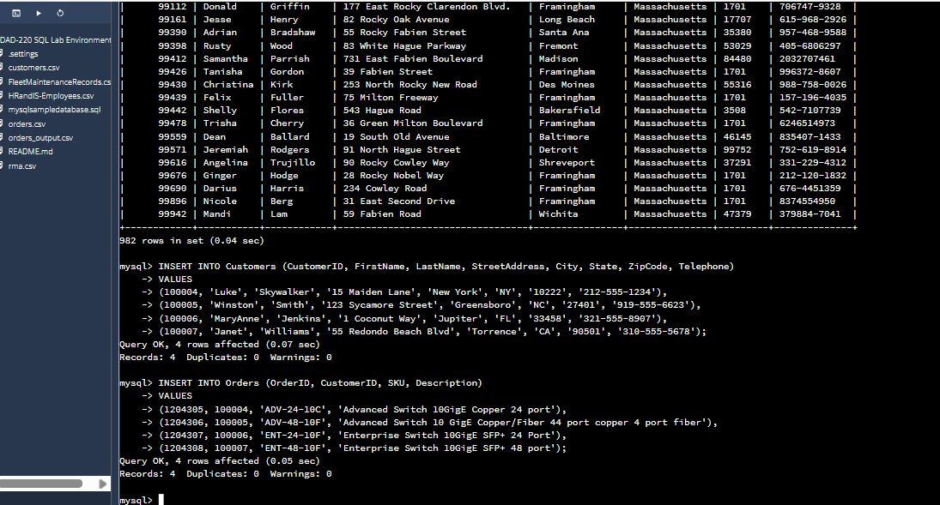

Orders Table
OrderID | CustomerID | SKU | Description
1204305 | 100004 | ADV-24-10C | Advanced Switch 10GigE Copper 24 port
1204306 | 100005 | ADV-48-10F | Advanced Switch 10 GigE Copper/Fiber 44 port copper 4 port fiber
1204307 | 100006 | ENT-24-10F | Enterprise Switch 10GigE SFP+ 24 Port
1204308 | 100007 | ENT-48-10F | Enterprise Switch 10GigE SFP+ 48 port



  - In the Customers table, perform a query to count all records where the city is Woonsocket and the state is Rhode Island.
    - How many records are in the Customers table where the field "city" equals "Woonsocket"?

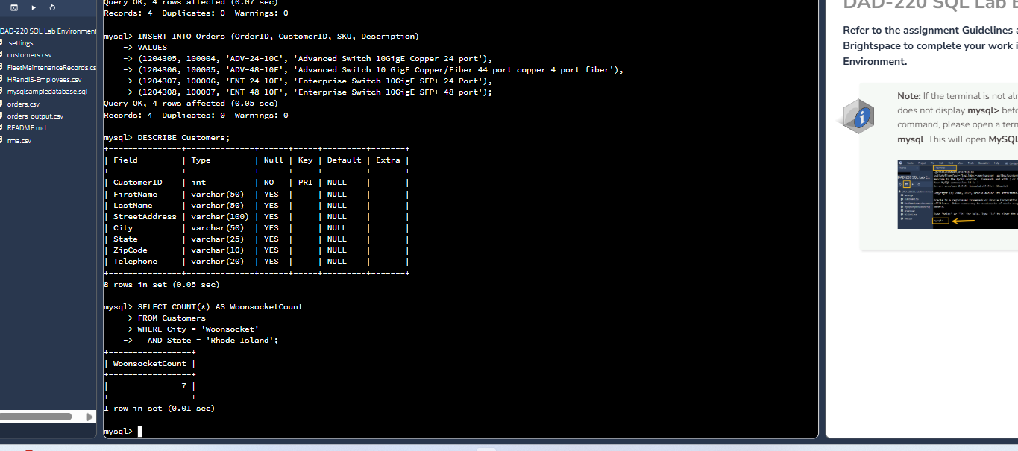
- This query counts how many customer records list their city as Woonsocket and their state as Rhode Island. The WHERE clause filters the Customers table to include only rows that match both conditions. The result shows that 7 customers are located in Woonsocket, Rhode Island.

  - In the RMA database, update a customer's records.
    - Write a SQL statement to select the current fields of status and step for the record in the RMA table with an OrderID value of "5175".
      - What are the current status and step?

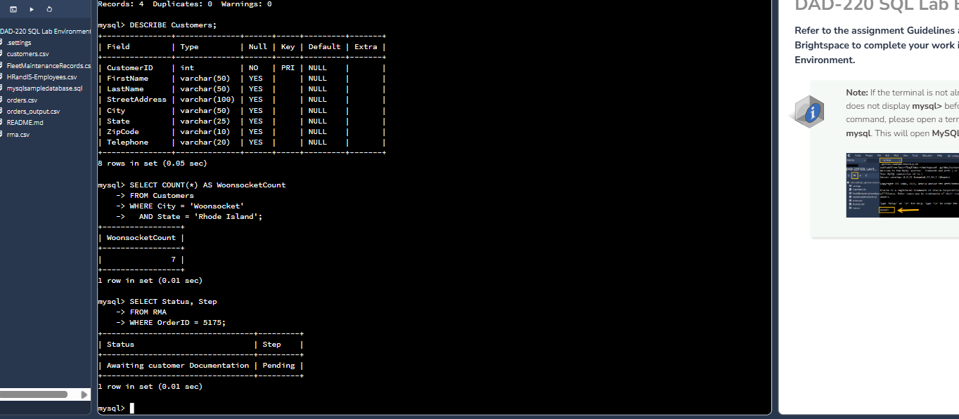

-The following query returns the present value of the Status and Step fields from the RMA table for the record with OrderID = 5175. You can see that this RMA is presently in the Awaiting customer Documentation status and that the next step is Pending.

    - Write a SQL statement to update the status and step for the OrderID, 5175 to status = "Complete" and step = "Credit Customer Account".
      - What are the updated status and step values for this record?

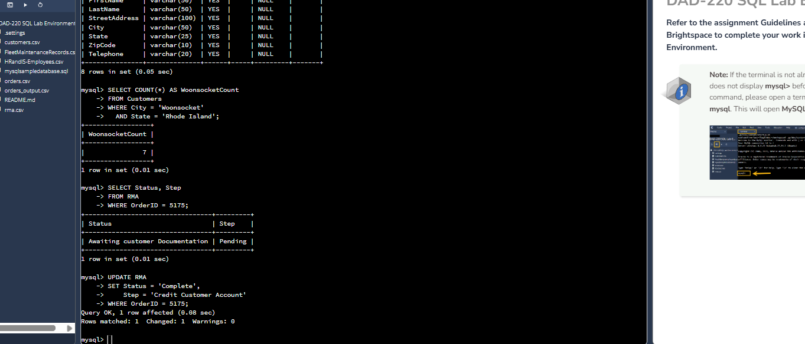

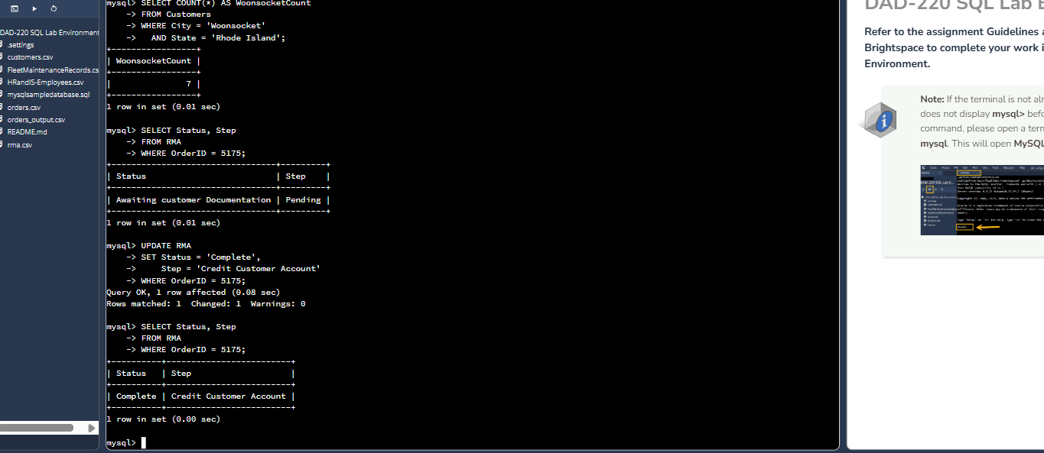
- This SQL update command modifies the RMA record associated with OrderID = 5175. The Status field is updated from “Awaiting customer Documentation” to “Complete”, and the Step field is updated to “Credit Customer Account.” This reflects that the RMA process for this order is now finished and ready for final credit processing.

  - Delete RMA records.
    - Write a SQL statement to delete all records with a reason of "Rejected".
      - How many records were deleted?

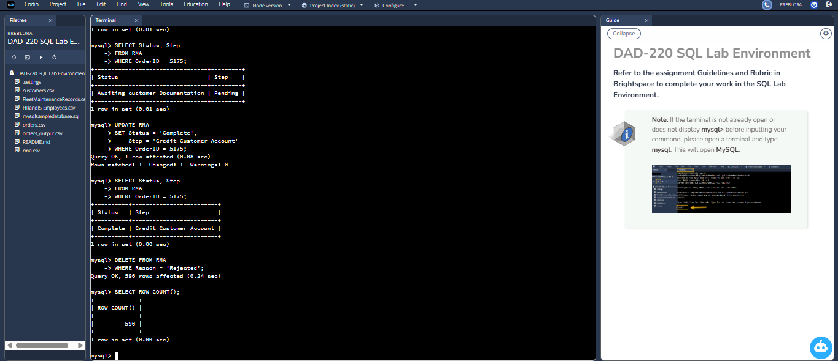

- To delete all the RMA records with reason “Rejected”, I utilized DELETE command with WHERE clause so that only the row with that specific reason was going to be deleted instead of clearing the whole table. I ran SELECT ROW_COUNT(); after the delete statement to see the number of rows that were deleted by MySQL.
It returns me that 596 records are deleted so there were 596 records in RMA table with reason of “Rejected”.

- Update your existing tables from "Customer" to "Collaborator" using SQL based on this change in requirements. Copy and paste the SQL you write to do the following action:
  - Rename all instances of "Customer" to "Collaborator".

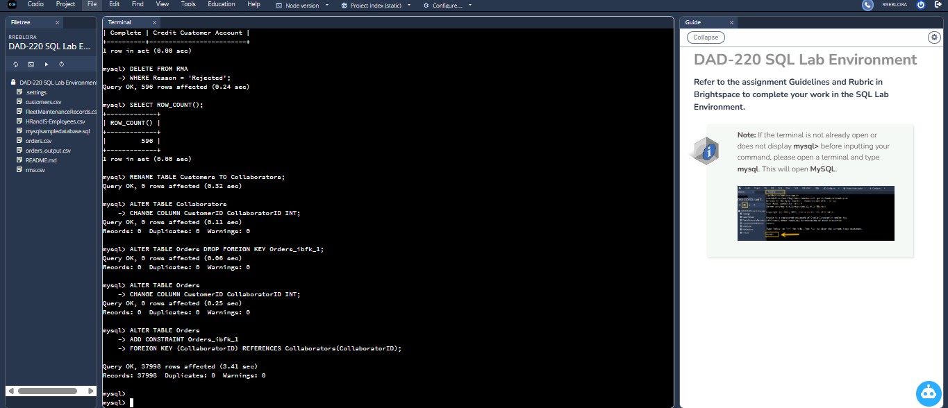

- Create an output file of the required query results. Write a SQL statement to list the contents of the Orders table and send the output to a file that has a CSV extension.

